Ta’oht iwahsohkou’tenh ?
«Which colour is it?»
Ahsohkwa’ «colour, dye, paint»
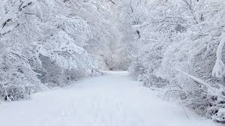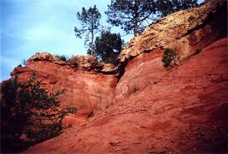
Öndinienhta’ ïohtih «it is like snow» Wenhta’ ïohtih «it is like ocher»
White Red
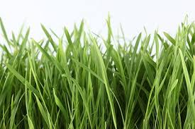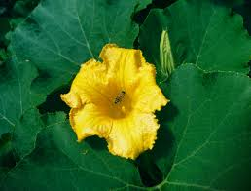
Enrou’ta’ ïohtih «it is like grass» Atiaren’ta’ ïohtih «it is like the pumpkin flower»
Green Yellow
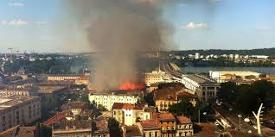
Yaronhia’ ïohtih «it is like the sky» Oushata’ ïohtih «it is like smoke»
Blue Brown
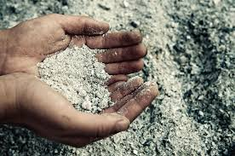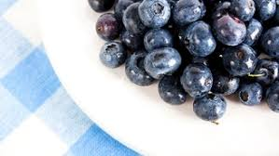
O’yenhra’ ïohtih «it is like ash» Ohenhtayet ïohtih «it is like le blueberries»
Grey Violet
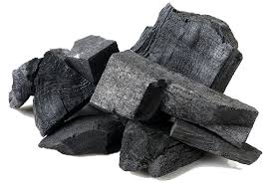
Yatsihenhstatsih « it becomes as dark as coal »
Black
Vocabulary : Nature

Yaronhia’ : sky
Nominal root: _______________________
Enrou’ta’ : grass
Nominal root: _______________________

Wenhta’ : ocher
Nominal root: _______________________

O’yenhra’ : ash
Nominal root: _______________________

Atiaren’ta’ : pumpkin flower
Nominal root: _______________________

Ohentayet : blueberry
Nominal root: _______________________

Oushata’ : smoke
Nominal root: _______________________

Öndinienhta’ : snow
Nominal root: _______________________

Otsihenhsta’ : coal
Nominal root: _______________________

